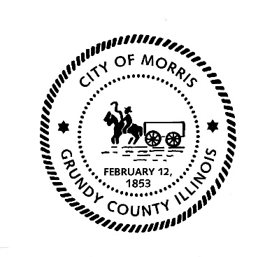
700 N. Division Street
Morris, IL 60450
Phone (815) 942-0103
Fax (815) 942-0216
Richard P. Kopczick, Mayor
Carol Adair, City Clerk
MaryBeth O’Brien, City Treasurer
CITY OF MORRIS

CITY OF MORRIS RAFFLE REPORTING FORM

The organization conducting the raffle shall furnish to the City of Morris documentation evidencing the organization’s gross receipts, expenses and net proceeds from each raffle and the distribution of net proceeds as required under Section 6 of the Raffles Act (230 ILCS 15/6) within thirty (30) days of the completion of each raffle. If a license is valid for more than thirty (30) days, the report shall be made monthly.

Please use this form to provide documentation:

Name of organization: ___________________________________________________________

Address: ______________________________________________________________________________

Raffle Manager: ______________________________________________________________________________

Date of raffle: ______________________________________________________________________________

Gross receipts from raffle: ________________________________________________________

Raffle expenses: ______________________________________________________________________________

Net proceeds from raffle: _________________________________________________________

The net proceeds from the raffle were distributed to whom (i.e. organization fund, individual, institution).

______________________________________________________________________________

This form will be filed with the organization’s original Raffle Application.

Return to: City of Morris
700 N. Division Street
Morris, IL 60450
cadair@morrisil.org
C:\Heather\My Documents\CITY OF MORRIS\Raffle Act\Raffle Reporting Form.docx

